***Decoders and Multiplexers***

**Submitted by:**

|  |  |
| --- | --- |
| **Name** | **ID** |
| Mariam ahmed | 96722 |

**Submitted to:**

Ms. Donthi Sankalpa

Lab Instructor

American University of Sharjah

College of Engineering

**Submitted on:**

Date: 22/10/2023

**Abstract**

In this lab we worked with both decoders and multiplexers while creating a truth table to verify our results. We also implemented our understanding of multiplexers into examples such as question 1.

**Introduction**

In this lab, we will work with both decoders and multiplexers on Logisim Evolution. We will also design combinational circuits on the software. We used the 74151 IC, which is an 8-1 multiplexer. Finally, we will create several truth tables to verify our theoretical results on the software.

**Theoretical Background**

Decoders take n of inputs and outputs 2^n. Each output corresponds to a unique input combination. We just have to design and use decoders to select one of the output lines based on the input. For a MUX we have 2^n inputs and n selection bits and one output. We understand the operation of multiplexers, including the number of input lines and how to select a specific input for the output.

**Experimental work, Results and Discussion**

This section will include the direct answers to the questions given in the lab script as well as any screenshots, tables or results required for the experimental work. These requirements will be stated by the lab instructor and on the lab script. This section should also include an over all discussion of the results with any unique findings if needed.

Q1)

In this exercise, we designed a circuit whchi represents the months of the year and the days

We first created a truth table for the days ( 1 meaing there are 31 days and 0 meaning there are 30)

* 1. List the truth table of the circuit.

|  |  |  |  |  |  |
| --- | --- | --- | --- | --- | --- |
|  | A | B | C | D | F |
| 0 | 0 | 0 | 0 | 0 | X |
| 1 | 0 | 0 | 0 | 1 | 1 |
| 2 | 0 | 0 | 1 | 0 | 0 |
| 3 | 0 | 0 | 1 | 1 | 1 |
| 4 | 0 | 1 | 0 | 0 | 0 |
| 5 | 0 | 1 | 0 | 1 | 1 |
| 6 | 0 | 1 | 1 | 0 | 0 |
| 7 | 0 | 1 | 1 | 1 | 1 |
| 8 | 1 | 0 | 0 | 0 | 1 |
| 9 | 1 | 0 | 0 | 1 | 0 |
| 10 | 1 | 0 | 1 | 0 | 1 |
| 11 | 1 | 0 | 1 | 1 | 0 |
| 12 | 1 | 1 | 0 | 0 | 1 |
| 13 | 1 | 1 | 0 | 1 | X |
| 14 | 1 | 1 | 1 | 0 | X |
| 15 | 1 | 1 | 1 | 1 | X |

We then implemented the circuit on Logisim and verified our results.

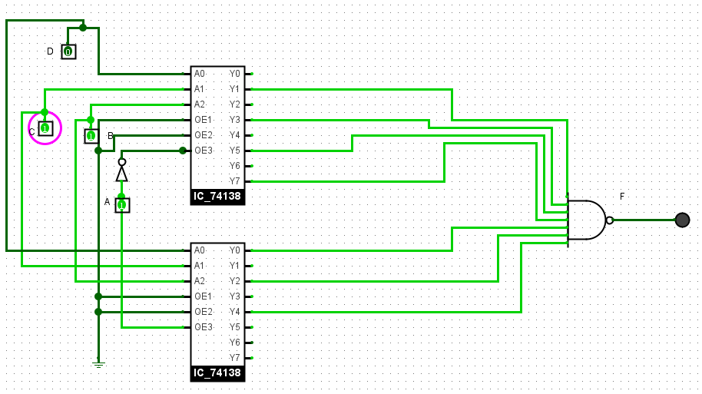

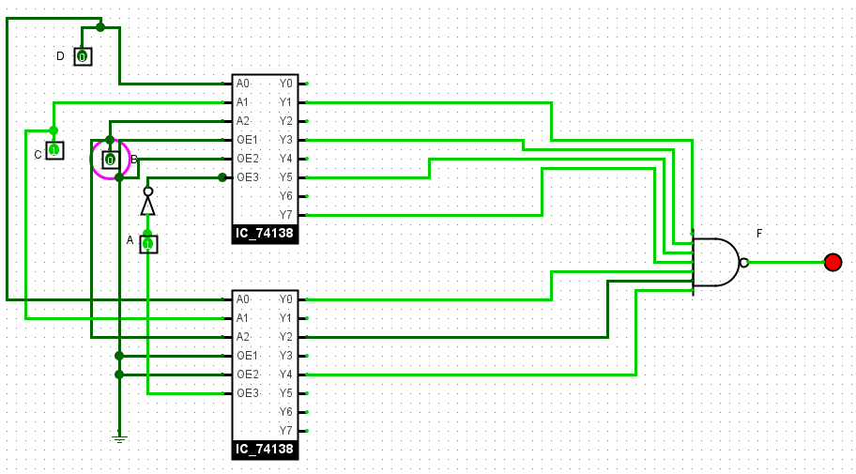

Q2)

In this exercise we implemented the following Boolean Function F (A, B, C, D) = ∑ (0, 4, 5, 7, 8, 9, 12, 15) on Logisim

Then we compared our circuits with our values from the truth table.

|  |  |  |  |  |  |  |
| --- | --- | --- | --- | --- | --- | --- |
|  | A | B | C | D | F |  |
| 0 | 0 | 0 | 0 | 0 | 1 | D' |
| 1 | 0 | 0 | 0 | 1 | 0 | D' |
| 2 | 0 | 0 | 1 | 0 | 0 | ground |
| 3 | 0 | 0 | 1 | 1 | 0 | ground |
| 4 | 0 | 1 | 0 | 0 | 1 | power |
| 5 | 0 | 1 | 0 | 1 | 1 | power |
| 6 | 0 | 1 | 1 | 0 | 0 | D' |
| 7 | 0 | 1 | 1 | 1 | 1 | D' |
| 8 | 1 | 0 | 0 | 0 | 1 | power |
| 9 | 1 | 0 | 0 | 1 | 1 | power |
| 10 | 1 | 0 | 1 | 0 | 0 | ground |
| 11 | 1 | 0 | 1 | 1 | 0 | ground |
| 12 | 1 | 1 | 0 | 0 | 1 | D' |
| 13 | 1 | 1 | 0 | 1 | 0 | D' |
| 14 | 1 | 1 | 1 | 0 | 0 | D' |
| 15 | 1 | 1 | 1 | 1 | 1 | D' |

We verified the circuit from the truth table and concluded that our circuit is correct.

Q3) F (A, B, C, D) = ∑ (0, 1, 4, 5, 7, 8, 12)

Don't care = d (2, 3)

We created a truth table based on the above formula.

|  |  |  |  |  |  |  |  |
| --- | --- | --- | --- | --- | --- | --- | --- |
|  | A | B | C | D | F |  |  |
| 0 | 0 | 0 | 0 | 0 | 1 | A | POWER |
| 1 | 0 | 0 | 0 | 1 | 1 | A | POWER |
| 2 | 0 | 0 | 1 | 0 | X | A | POWER |
| 3 | 0 | 0 | 1 | 1 | X | A | POWER |
| 4 | 0 | 1 | 0 | 0 | 1 | B | C' + D |
| 5 | 0 | 1 | 0 | 1 | 1 | B | C' + D |
| 6 | 0 | 1 | 1 | 0 | 0 | B | C' + D |
| 7 | 0 | 1 | 1 | 1 | 1 | B | C' + D |
| 8 | 1 | 0 | 0 | 0 | 1 | C | C'D' |
| 9 | 1 | 0 | 0 | 1 | 0 | C | C'D' |
| 10 | 1 | 0 | 1 | 0 | 0 | C | C'D' |
| 11 | 1 | 0 | 1 | 1 | 0 | C | C'D' |
| 12 | 1 | 1 | 0 | 0 | 1 | D | C'D' |
| 13 | 1 | 1 | 0 | 1 | 0 | D | C'D' |
| 14 | 1 | 1 | 1 | 0 | 0 | D | C'D' |
| 15 | 1 | 1 | 1 | 1 | 0 | D | C'D' |

Then we implemented this on Logisim Evolution using the IC_74153 (4-1 multiplexer) to verify our results.

After simulating the circuit, we can conclude that our truth table is accurate.

**Conclusion**

To conclude this lab, the exercises have provided us with a comprehensive comprehension of the principles and functionality of decoders and multiplexers, which are fundamental elements in digital circuits. Through practical, hands-on activities, we have acquired valuable experience in designing and implementing efficient digital systems utilizing these components. Moreover, our understanding of how decoders and multiplexers are employed in memory and communication systems equips us with the knowledge to apply these concepts in future electrical and computer engineering courses. In essence, this lab has established a strong foundation in the basics of digital electronics and has equipped us to create and deploy efficient and effective digital systems incorporating decoders and multiplexers.